Task 1: this plot is trying to show the growth in car exports for 4 regions during the years 1927, 1928, and 1929. Besides being rather racially insensitive (the plot was made back in the 70s), the plot is rather misleading. What is misleading about it, i.e., fundamental flaw(s) exist in how this data is being presented? Create plot that provides a much improved way of presenting the data below this plot (or on the next page).

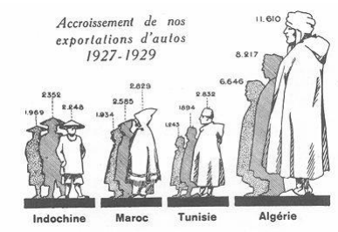

Note: the numbers, as far as I can tell from the resolution plot, read (from left to right)
1969, 2352, 2248, 1934, 2585, 2629, 1243, 1694, 2832, 6646, 8217, 11610

Task 2: the following plot is trying to show a few things:
- How Black Home Ownership has changed over time (2004-2016)
- How Black Voter Turnout has changed over time (2004-2016)
- How these two quantities are related.
- How these quantities and their relationship differ across six states.

It’s a mess.

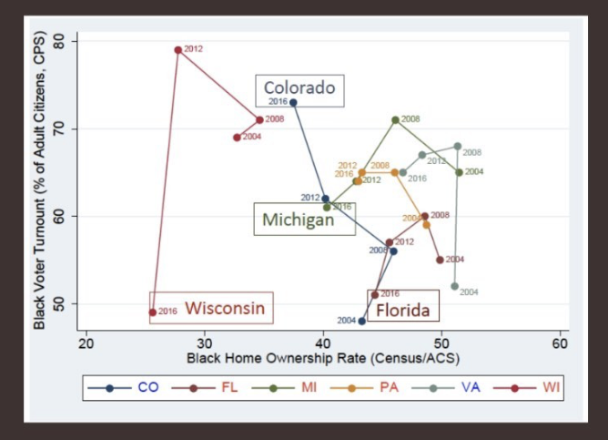

Create a plot (or two, or three…however many is necessary) that provides a much improved way of presenting the data. Copy/paste into this document.

